【方法一】
1.进入“浙大钉”APP，点击底部中间“求是鹰”标识，进入浙江大学工作台；
2.点击“健康打卡”模块，即可进入健康打卡界面；
3.首次登陆，请要求填写“基本信息”（只需要首次登录时填写），请一定要保证各项信息准确无误，确保能通过填写的手机号联系到本人，填写完成后点击页面下方的提交按钮；
4.每天上午12:00前填写“日常健康报备”信息，即为完成当日健康打卡。每天只能提交一次，不可修改，填写完点击底部“提交信息”按钮。
Method A:
1.Enter “ZJU Ding Talk” and click the emblem of “Qiushi Eagle” at the bottom， and then log onto ZJU Interface.
2.Click “健康打卡”, log in the health report system .
3.Please fill the basic personal information(Only for the first time) . Please make sure every information is correct and the cellphone can be contacted to you. You should submit it after finishing the form.
4.Fill and submit the daily heath report information before 12:00 noon everyday. You only can submit it one time each day,and cannot modify it, please submit the information after filling it.
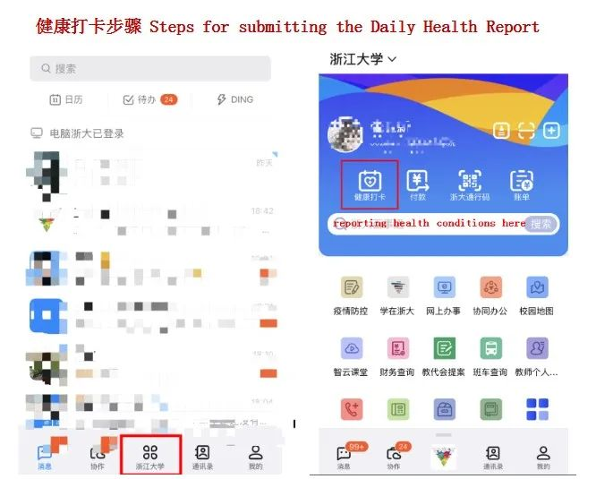

【方法二】
1.微信搜索“浙大校务服务”或“zjubsdt”，关注“浙大校务服务”公众号；
2.点击“网上办事”-“浙大健康打卡”模块，用学号登陆统一身份认证，即可进入健康打卡界面；
3.首次登陆，请要求填写“基本信息”（只需要首次登录时填写），请一定要保证各项信息准确无误，确保能通过填写的手机号联系到本人，填写完成后点击页面下方的提交按钮；
4.每天上午12:00前填写“日常健康报备”信息，即为完成当日健康打卡。每天只能提交一次，不可修改，填写完点击底部“提交信息”按钮。
Method B:
1.Search “浙大校务服务” or “zjubsdt” in Wechat and add the WeChat official account “浙大校务服务”.
2.Click “网上办事”—“浙大健康打卡”, log in the health report system by using the “统一身份认证”.
3.Please fill the basic personal information(Only for the first time) . Please make sure every information is correct and the cellphone can be contacted to you. You should submit it after finishing it.
4.Fill and submit the daily heath report information before 12:00 noon everyday. You only can submit it one time each day, and cannot modify, please submit the information after filling it.
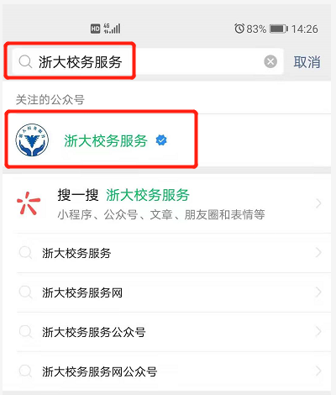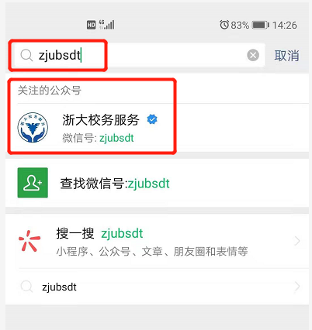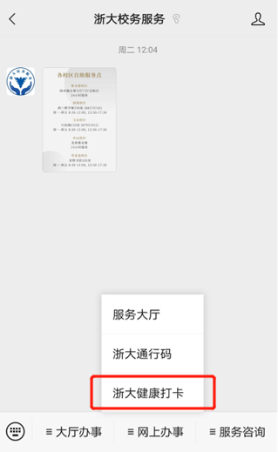
说明：统一身份认证用户名为个人学号（请在个人招生申请账号查询），初始密码为：zju加护照后四位，例如:zju1065。统一身份认证可实现学校多个信息系统的登录服务，为保障个人信息安全，请首次登录后及时修改密码。
Note: The user name of “统一身份认证” is your Student ID number, the initial password is ZJU plus the last four digits of the passport, eg.: zju1065. “统一身份认证” can be used to log in different system. Please change your password in time after logging in for the first time.

