方式一：浙大钉
Method A: Zju Dingtalk “浙大钉”
浙大钉-浙大通行码-申请流程-学生通行码申请
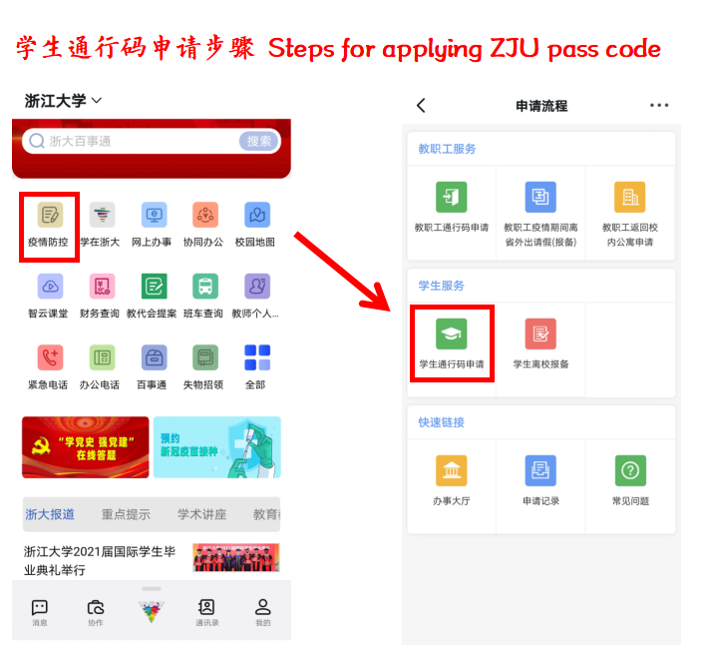
方式二：微信公众号“浙大校务服务”
Method B: Wechat platform “浙大校务服务”
“浙大校务服务”公众号—网上办事—统一身份证登录—申请流程—学生通行码申请
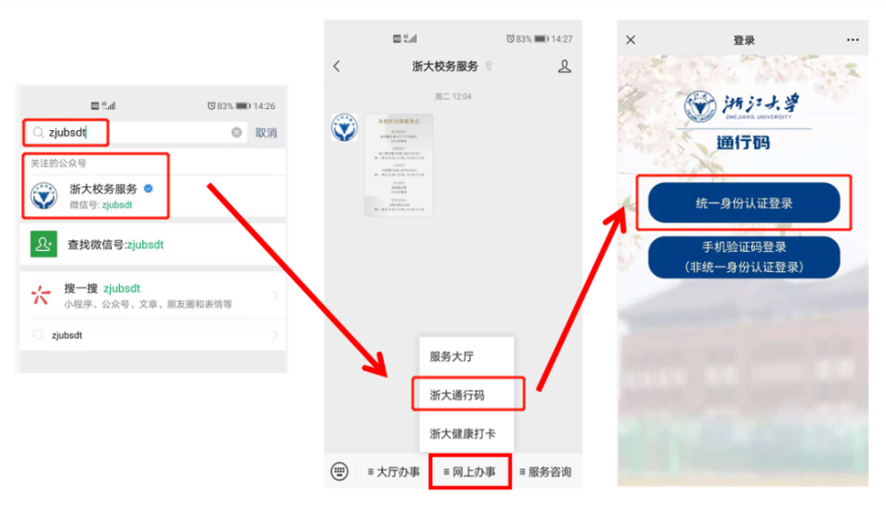
【注意事项】
1.入校前请提前接种新冠疫苗，到校前第三天、第一天进行核酸检测，经学校审批后生成浙大通行码“蓝码”。到校后到指定地点进行核酸检测（具体安排请关注钉钉群内通知）；
2.到校后请减少非必要外出，不串门，不聚集，离开宿舍请严格佩戴口罩；
3.在校期间，注意个人防护，继续坚持每日健康打卡。连续1天未按要求进行健康打卡，浙江大学通行码（蓝码）将自动取消。”
Special Attention
1.Please take the COVID-19 vaccine in advance before entering the campus. Nucleic acid test should be conducted three days and one day before entering the campus. The "blue code" of Zhejiang University will be generated after approval by the university. Nucleic acid testing shall be carried out at the designated place upon arrival (please pay attention to the notice within Dingding group for specific arrangements);
2.Please do not go out unnecessarily, do not drop around, do not gather together, and wear a mask when leaving the dorm;
3.Pay attention to personal heath, and submit the Daily Health Report everyday. If missing one day, the ZJU pass code (blue code) will be canceled by the system automatically.

